CK24 -

Functionality
Once you have carried out a cost estimate for a material without any errors, you can transfer the costing results to the material master as prices.
To set a new standard price in the material master, you must mark and release the standard cost estimate. Before you can mark and release a standard cost estimate, you must allow standard cost estimates to be marked and released in a company code.
If you mark a standard cost estimate for a material, the price calculated in the standard cost estimate is transferred into the material master record as the future standard price.
You can repeat the marking at any time. However, this can only be done once in a period.

Scenario
Mark a standard cost estimate for the material 64 – Butane -1 in the plant 1200. The price calculated in the standard cost estimate is to be transferred into the material master record as the future price.

Requirements
The cost estimate has the status ‘KA: Costed without errors’. Only the results of cost estimates without errors can be updated.

Menu Path | Accounting → Controlling → Product Cost Controlling → Product Cost Planning→ Material Costing → CK24 - Price Update
Transaction Code | CK24

1. Double click on CK24 - Price Update.

Price Update: Mark Standard Price

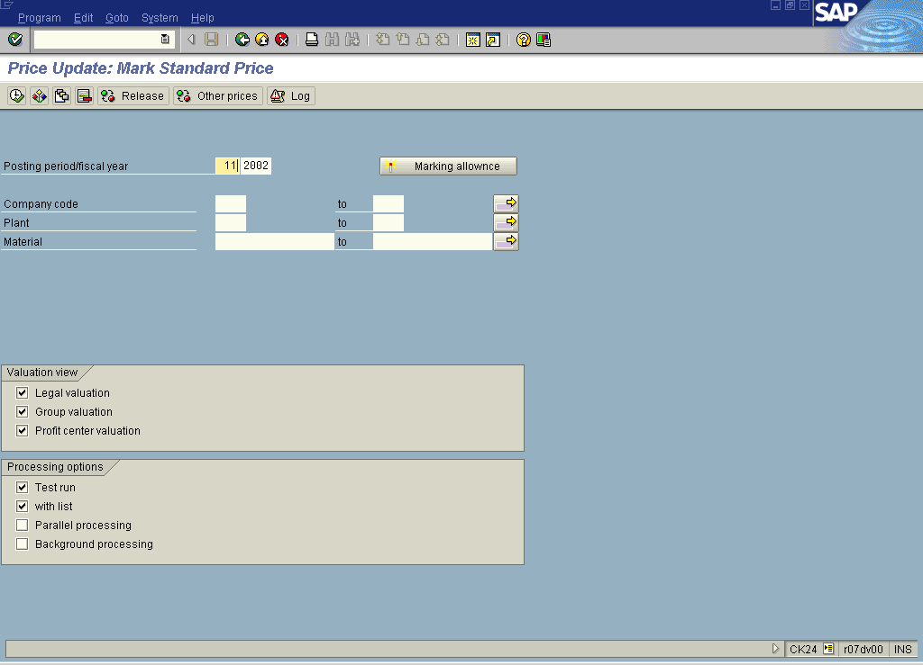

2. Click the Marking allowance button.

Price Update: Organizational Measure

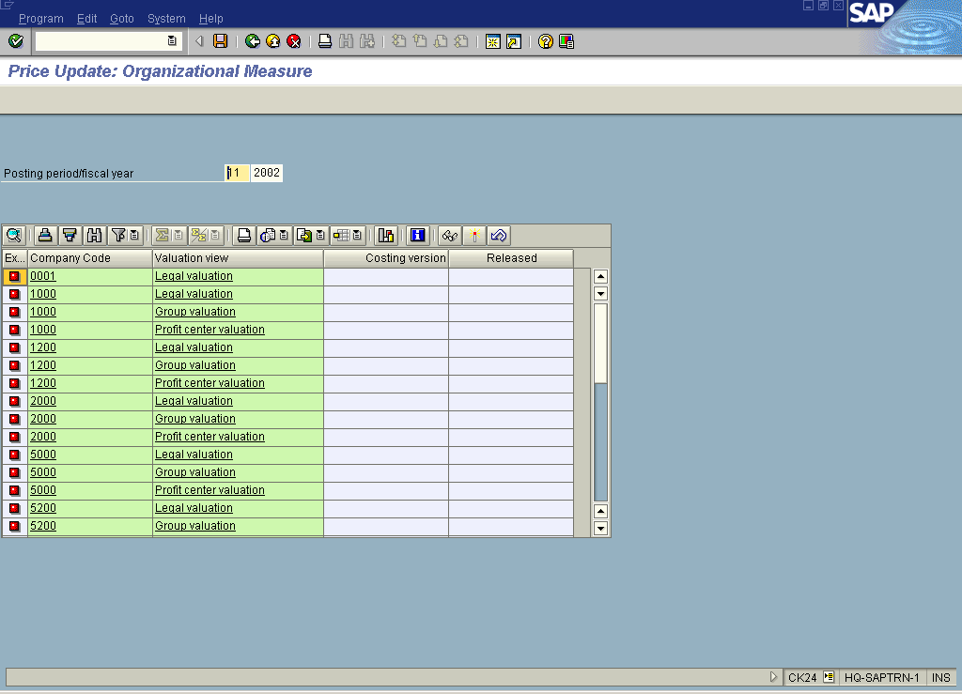

3. Select the 1200 Legal valuation line and press the Issue marking allowance button.

Permitted std. cost est. variant

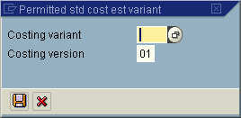

Permitted std. cost est. variant

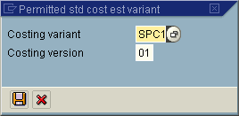

4. Click the Save button.

Price Update: Organizational Measure

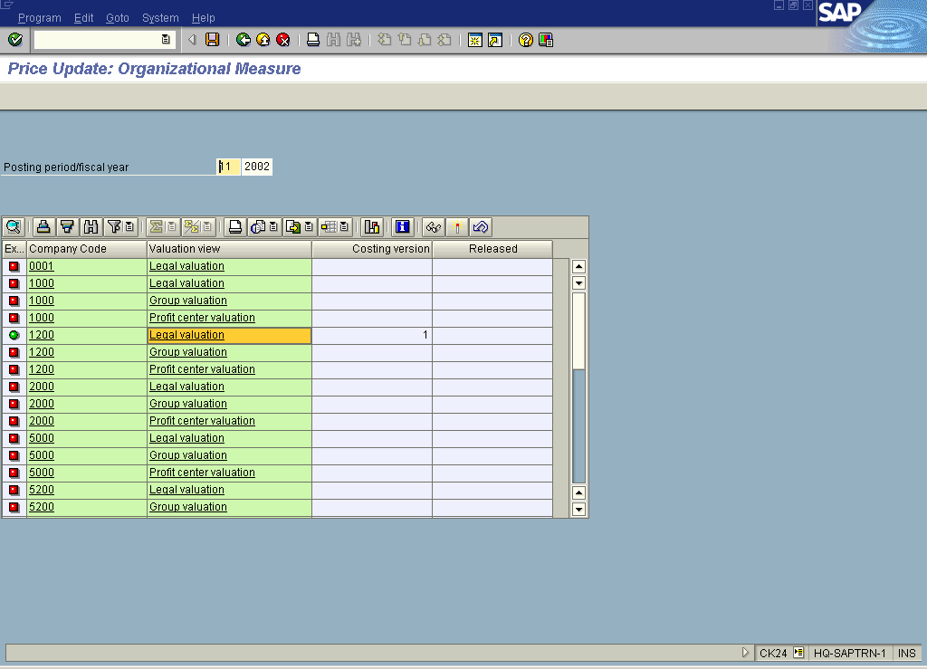

The steps from here are being executed because material ledger is activated with 3 valuations Legal valuation, group valuation and profit center valuation.

5. Select the 1200 Group valuation line and Click the Issue marking allowance button.
6. Update the following fields:

Field Name | Field Description | Values
Costing variant | Key that determines how a cost estimate is performed and valuated. | Example: SPC2
7. Click the Save button.

8. Select the 1200 Profit center valuation line and Click the Issue marking allowance button.
9. Update the following fields:

Field Name | Field Description | Values
Costing variant | Key that determines how a cost estimate is performed and valuated. | Example: SPC3
10. Click the Save button.
11. Click the Back button.

Price Update: Mark Standard Price

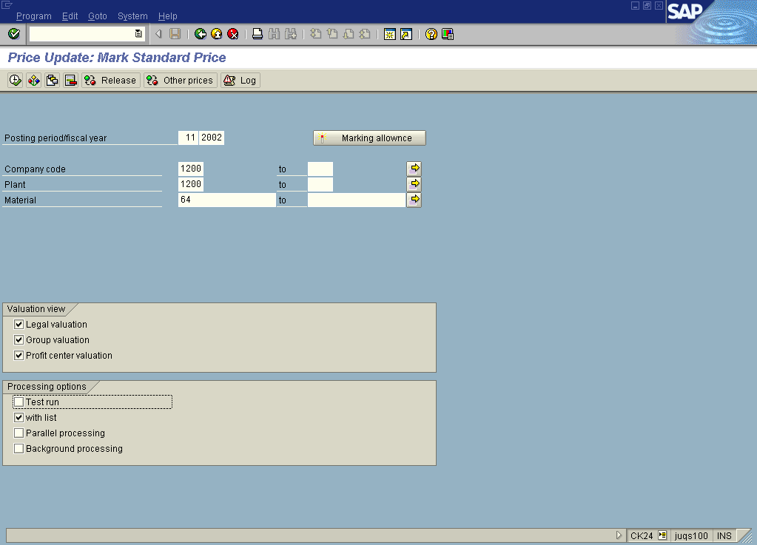

12. Update the following fields:

Field Name | Field Description | Values
Company code | Code identifying the company purchasing the material | Example: 1200
Plant | Code identifying the operational unit of the company where the material is manufactured and stored | Example: 1200
Material | Code identifying a product or component | Example: 64

13. Click the Test run checkbox to deselect.
14. Click the Execute button.

15. Click the Back button.
Price Update: Mark Standard Price

16. Click the Back button to go back to SAP Easy Access screen.

